**Analysis task**

* **Blend the data with the Saved Sample - Sales Target data set to bring in the Sales Target measure.**

By clicking on New Data Source add Sales Target data set selecting edit blend relationship below box will appear select the identical columns/dimensions (Category, Order date, Segment) and relationship will be established.

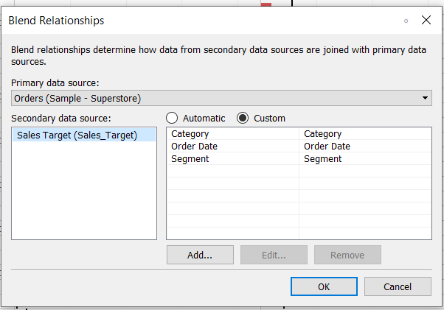

As we can see in the below image the relation between two datasets have been established successfully. The red connection symbol will appear on the right side of dimensions i.e. (Category, Order Date, Segment).

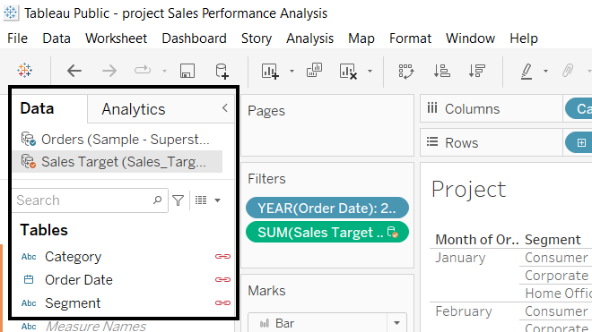

* **Color code the chart to identify Categories and Segments that are above or below target.**

I have used calculated fields for color code as below.

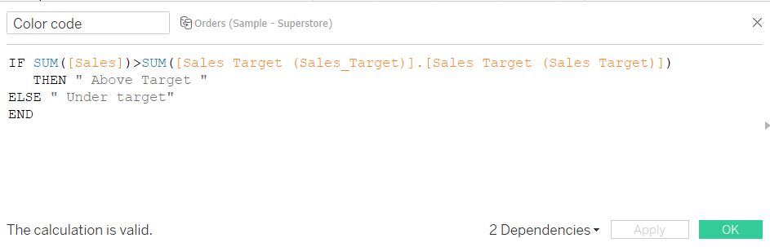

* **Add the year of sales to the view to identify trends and outliers.**
* **Add a filter so that the user can select one, more than one, or all years.**

Add filter for order date year wise and then show filter.

Filter will appear on the right side of the worksheet.

User can select one, more than one, or all years.

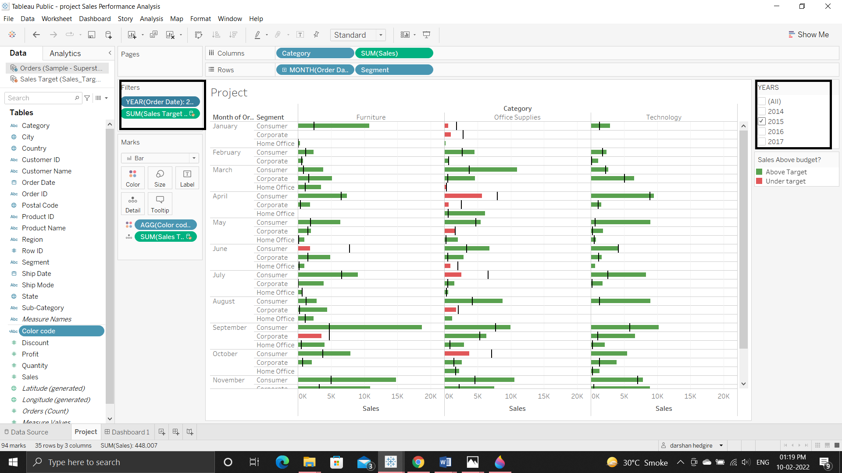

**Created a dashboard.**

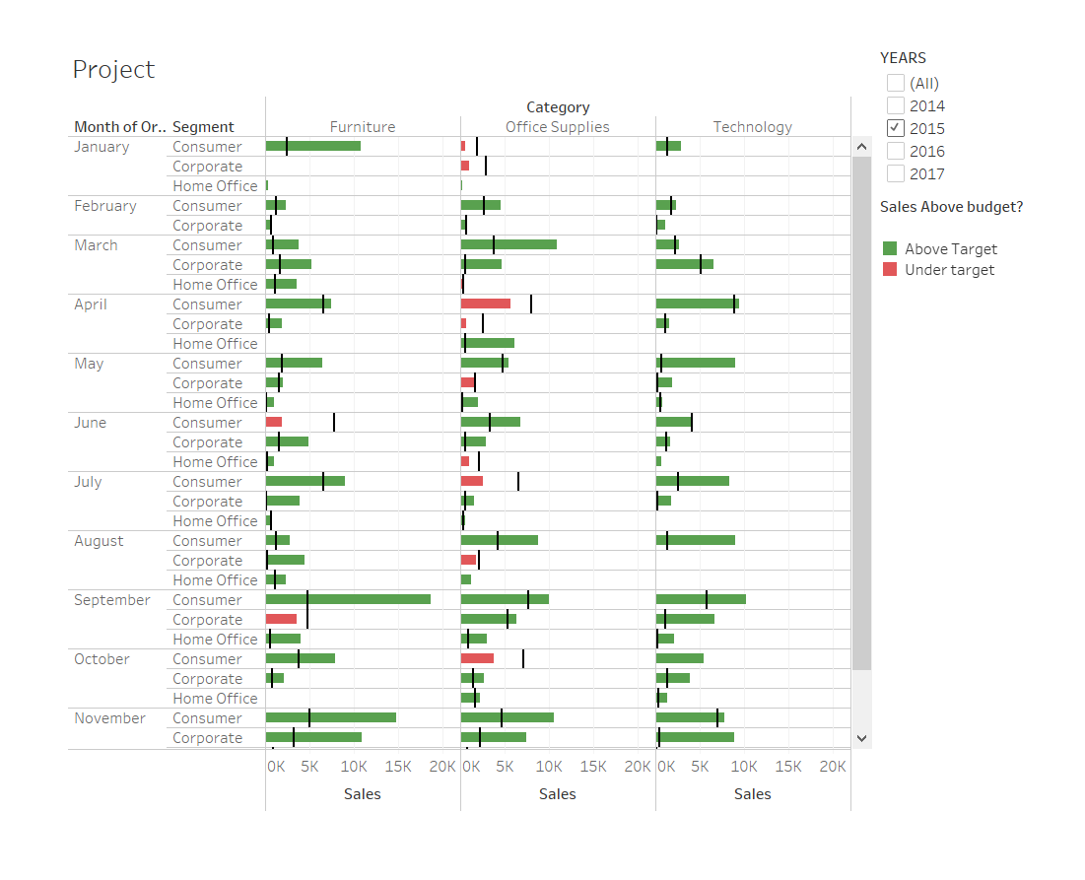

Tableau public link:

https://public.tableau.com/app/profile/darshan.hedgire/viz/projectSalesPerformanceAnalysis/Dashboard1?publish=yes